Electric Petrol Perimeter Design

Purpose
This submission provides a perimeter design for Electric Petrol using FortiGate firewalls. It includes Internet connectivity, site-to-site VPNs, DMZ services, and remote access controls.
Topology Diagram

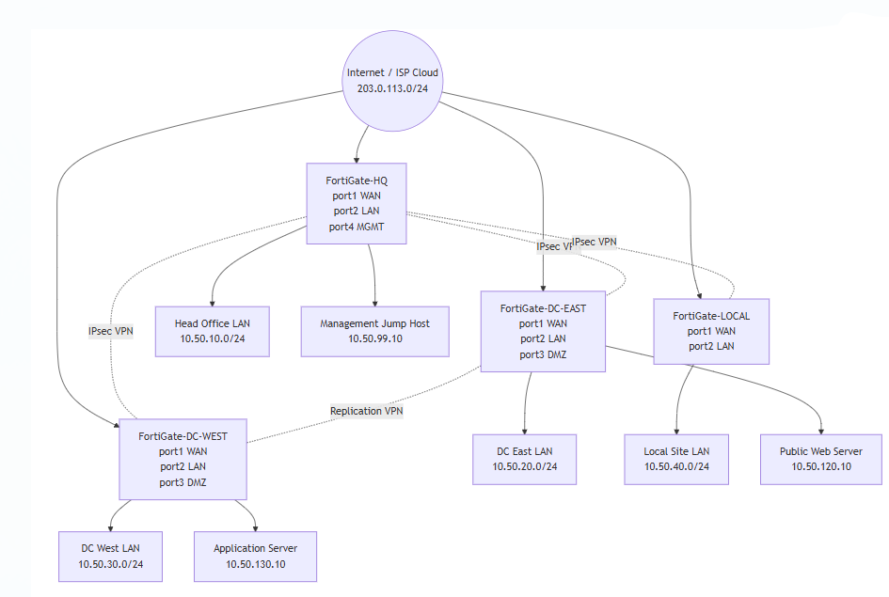

Addressing Plan

Zone | Network | Gateway / Host
ISP / Internet | 203.0.113.0/24 | 203.0.113.1
Head Office LAN | 10.50.10.0/24 | 10.50.10.1
HQ Management | 10.50.99.0/24 | 10.50.99.1
DC East LAN | 10.50.20.0/24 | 10.50.20.1
DC East DMZ | 10.50.120.0/24 | 10.50.120.1
DC West LAN | 10.50.30.0/24 | 10.50.30.1
DC West DMZ | 10.50.130.0/24 | 10.50.130.1
Local Site LAN | 10.50.40.0/24 | 10.50.40.1
SSL VPN Pool | 10.50.250.0/24 | Assigned by FortiGate-HQ

Internet Connectivity
Each FortiGate uses port1 as the WAN interface and has a default route to 203.0.113.1. LAN-to-Internet firewall policies use NAT.
Site-to-Site VPN Design
Tunnel | Purpose
HQ-to-DCE | Headquarters to DC East LAN and DMZ
HQ-to-DCW | Headquarters to DC West LAN and DMZ
HQ-to-LOCAL | Headquarters to Local Site LAN
DCE-to-DCW | Data centre replication / DR traffic

The VPNs use IKEv2, AES256/SHA256, DH group 14, and NAT is disabled on VPN policies.
DMZ Services

Service | Location | DMZ IP | Public IP / VIP
Public Web Server | DC East DMZ | 10.50.120.10 | 203.0.113.20 HTTP/HTTPS
Application Server | DC West DMZ | 10.50.130.10 | 203.0.113.30 HTTPS

DMZ services are separated from the internal LANs. Public users can access only published VIP services.
Results Section
Paste actual command output/screenshots here after testing.
Internet Test
execute ping 203.0.113.1
Expected: successful replies.
VPN Tunnel Test
get vpn ipsec tunnel summary
diagnose vpn tunnel list
Expected: tunnels up and counters increasing.
Site-to-Site Ping Test
execute ping-options source 10.50.10.1
execute ping 10.50.20.1
execute ping 10.50.30.1
execute ping 10.50.40.1
Expected: all successful.
DMZ Tests
curl http://203.0.113.20
curl https://203.0.113.20
curl https://203.0.113.30
Expected: published DMZ services respond.
Negative Security Tests
ping 10.50.20.100
ping 10.50.30.100
curl http://10.50.120.10
Expected: blocked from Internet side.

